CSCE 5430 SOFTWARE ENGINEERING

9/30/2020

Group Name: Mystic Gang

Group Members: Abhinav mAmidipelly

Harshavardhan reddy golli

prakyath reddy kandimalla

udhaya kumar gutta

Image Based Food Size and Calorie Estimation

Using CNN Classifier

**Table of Content**

1. Introduction 3

1.1 Purpose 3

1.2 Scope 3

2 structure of the Application 4

Figure 1: Structure of the system 4

2.1 Admin 5

2.2 User 5

2.3 Run Application 5

2.4 User Interface 5

2.5 Functionality Programs 6

2.6 Database 6

3 System Requirements 7

3.1 Non-functional Requirements 7

3.1.1 Performance 7

3.1.2 Usability 7

3.1.3 Security 7

3.1.4 Capacity 7

3.1.5 Data integrity 7

3.1.6 Scalability 7

3.2 Functional Requirements 8

3.2.1 Admin 8

3.2.2 User 8

3.3 Interfaces 9

4 Implementation plan 10

Figure 2: Process flow of the system 10

4.1 Development phase 1 11

4.2 Development phase 2 11

4.3 Development phase 3 11

5 References 12

# Introduction

In the current generation, obesity is a significant health issue in the United States of America. It causes numerous health issues like diabetes, stroke high blood pressure, and it may lead to many cancers related problems. The main reason for obesity is the increased consumption of food and calories. To overcome obesity, people need to calculate calories before taking it. But for calculating the calories of the food, we need to know food details what we are taking and calories information, but this is tough in practice because of many cultures and food habits. The United States of America is a large country with many cultures, each culture has their unique food habits, and food items will be there. Collecting the calories information of all these types of food is very tough. So, we are trying to develop an application that identifies the food name from the image to retrieve the calories of the food based on the amount we are consuming. For this, we are using the CNN model for prediction of food name from the image.

## Purpose

The primary purpose of developing this application is to know the details of the food we are taking; most of the time, we depend on the outside food due to our modern lifestyle. In the present situation, we are eating different types of food, those we don’t know the exact details of the food item like ingredients, calories, etc. We need to know about the calories we are taking even we don’t know about the name of the food item. So, we are trying to develop an application which is an initial step to start an application which tells you about the food item details.

## Scope

We have minimal applications like the caloriecontrol.org web app to know the calories of a food item. But these services are minimal and not user friendly. Suppose we know about the calories of food; we need to know about the food's necessary information like name of food and ingredients of the food. But we require an application that will make user friendly by uploading the food image it will give the calories of the food item.

# structure of the Application

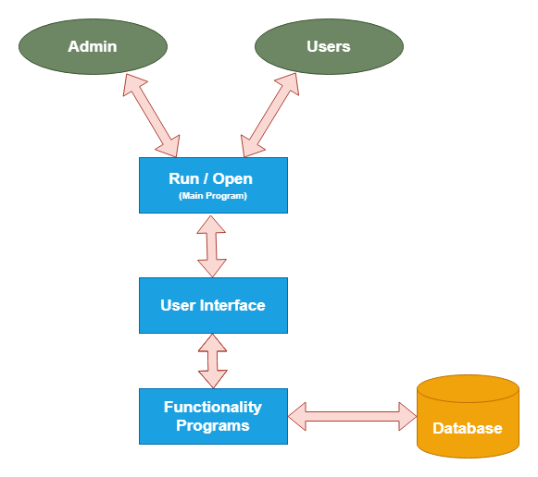

Figure 1: Structure of the system

In our system architecture, we have two major modules, i.e., admin and users. Whenever user or admin wants to use the application, they should run our desktop application by clicking or running our application's main program. After running the application, the user interface (admin or users), and then login into their portals using the application's login option, user interface actors can perform their specified functionality and store or retrieve data from the database.

## Admin

Admin plays a prominent role in our application. Admin is responsible for maintaining the data of food categories image dataset and training images for prediction at the user side functionalities. Admin also uploads the calorie dataset into the database of food items. This dataset includes the name of the food and calorie of food items as per a gram. Admin needs to maintain the application with a user-friendly and accurate prediction of food images and calories estimation.

## User

The user is an end-user of our application. To login to the user portal, the user can register from our application, and based on the registration login details; they can log in to our application. The user portal user can upload a food item image, and s/he should enter the size of the food in grams. The application will predict the food name from the image and collect the calorie data from the database based on food name and return food and calorie information based on size to the user.

## Run Application

To start any desktop application, we should create/run the primary or initial program of application. To start the main program, we have many procedures like beginning the main program from the command prompt or starting the application by clicking on an executable file. In a python programming language, by default, every python program works as an executable file. So, by clicking on the main program or python file, we can have our application interface.

## User Interface

User interfaces of desktop applications are simple and powerful. User interfaces of our application, helping actors to achieve their functionality goals directly. For our application, we used the PyQt toolkit for building user interfaces of the application. For designing PyQt user interfaces, we need to follow two steps.

1. Design frontend form with QT designer software. After designing the layout, we can save it into the ‘.ui’ file format.
2. Covert frontend form into python code by using the public(Python User Interface Compiler). It is a compiler of PyQt for the conversion of the ‘.ui’ file to the ‘.py’ file.

## Functionality Programs

After converting the PyQt design form, we need to build all user interface files' functionality action. Based on every design form component, we need to develop the business logic. For example, In Qt designer, we build an interface of the registration page. But the business logic of the registration page is collecting the field's data and store into the database in a suitable table. We assign a functionality program for the 'Register' button and create a data connection and store it using the SQL query.

Based on the functionality programs, every business logic and flow of the application will navigate. Based on user inputs on interface functionality, code will execute. According to the requirements, functionality programs will connect to the database for storing and retrieving the data.

## Database

A database is nothing but software that provides security for unauthorized access to data and data manipulations using RDBMS concepts. Application data will store in the database for permanent storage and retrieve data by using programmatically. The database server works based on RDBMS concepts, which means the software's operations are processed based on SQL queries. Using SQL queries, we can store, retrieve, update, delete, and so many functions.

# System Requirements

## Non-functional Requirements

Non-functional requirements always focus on the application external features like performance, security, performance etc. in different backlogs.

### Performance

Our application has high performance, as it depends on the training of data into the CNN classifier. As we increase, more filter performance increases

### Usability

It is very simple and user-friendly to use, it has very straight forward options for both admin and users.

### Security

It protects user data and food products data information, only admin has access to the data read and retain.

### Capacity

It depends on the memory management in our application. As we are training 10 food items.

### Data integrity

Our application has data accuracy and data performance as we will be training our data with several images of food items. We are expecting the data to process in faster and accurate manner.

### Scalability

The application is scalable as we can also train more food items if necessary, for the user. But due to memory management we are considering few food items.

## Functional Requirements

Functional Requirements describe of an application or software features, dataflow, and behavior of user/admin etc. Requirements for functional software assist you capture the user’s behavior.

### Admin

Main user of application

1. Login

Admin should login for authentication when s/he wants to access admin portal.

1. Train Dataset

Admin should train the food categories with lot of images with CNN algorithm for prediction of food item from the image.

1. Upload Calories Information

For trained images, the admin needs to maintain the calorie's grams' data to calculate the user side's calorie prediction.

1. View Dataset

For verification purpose admin can view the calories dataset from the admin portal.

### User

End user of application

1. Register

For accessing the user portal, the user should log in to the application. To get the login pattern, the user can register by providing information like name, email, password, etc. This data will store in the database.

1. Login

For accessing the user portal, the user should log in with email and password, which is provided during registration.

1. Prediction

In this function, the user must provide two input data, namely the food image and number grams of the food. The application will predict a the name of the food and calculate calories.

## Interfaces

For our application, we developed a software interface application only. It allows connecting with both admin and users. And it’s completely individual, there is no need of communication of multiple users. We used MySQL database for our application and used python coding language. For front end design, we have used PyQt tools to create desktop applications.

Below are the software interfaces that will be used.

1. Database: MySQL
2. Tools Required: PyQt, Pyuic, and TensorFlow
3. Technologies used:

a. Front end: PyQt

b. Language: Python

# Implementation plan

The implementation of our system is divided into three development phases and includes the below given requirements.

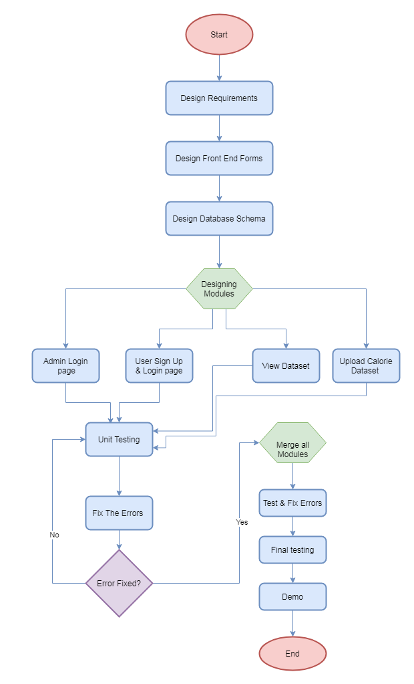

Figure 2: Process flow of the system

## Development phase 1

As already requirement gathering is done. In this stage, designing the requirements, database schema design and front-end design will be done. In requirement gathering we observed many applications which has disadvantages while providing calorie information. In our current application we analyze and detection food calories which is user friendly, user need to know calories of the food by uploading of an image. We design admin and user functionalities which are explained in functional requirement section.

Database Schema creation includes creation of tables for admin, user and dataset. The application design is also implemented in this phase.

## Development phase 2

In this development phase we will be implementing admin login page, user login page and signup page, dataset uploading page of admin, view option for admin. We test these individual modules after completion of business logic with data verify in the database with different input data. We develop full functional code implantation of a few admins and user functionalities, as mentioned in the functional requirement section.

## Development phase 3

In the third development phase the implementation of training of food images and predictions with multiple photos. We verify all the module's performance, which are mentioned in the requirements. After completion of implementation, we check with various tests and numerous data. If any errors occur, we fix those errors and test it again. After selecting all the individual modules, errors need to be rectified and run the full project demo multiple times to make it ready for the final project demonstration.

Members Contribution Table

|  |  |  |
| --- | --- | --- |
| Member name | Contribution description | Overall Contribution (%) |
| Abhinav Mamidipelly | Introduction, Structure of the Application | 25 |
| Harshavardhan Reddy Golli | System Requirements (Functional, Non-Functional and Interfaces) | 25 |
| Prakyath Reddy Kandimalla | Development Phases | 25 |
| Udhaya Kumar Gutta | Checking the overall flow of the document | 25 |

# References

1. <https://caloriecontrol.org>
2. <https://www.tutorialspoint.com/sql/sql-rdbms-concepts.htm>
3. <https://www.tutorialspoint.com/pyqt/index.htm>
4. <https://www.tutorialspoint.com/python/index.htm>
5. <https://en.wikipedia.org/wiki/Obesity_in_the_United_States>